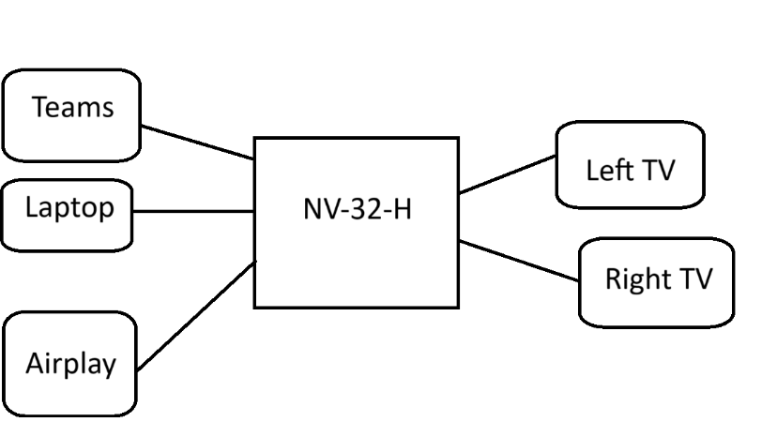

Scope of Work

* Sources = Teams, Laptop, Airplay
* Displays = Left, Right

It should be easy enough that someone with no experience or memory of the outside world can use it.

Use our brand colors

We want a picture from our design team on the touch panel background.

Don’t tell anybody about the goats